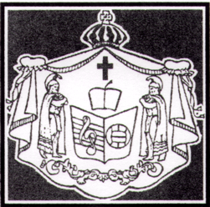

Haili Volleyball Tournament
c/o Lyndell K. Lindsey
131 Manulele St.
Hilo, HI 96720
Ph. (808) 896-3358
lyndylindsey@gmail.com

Aloha everyone,
In March of 2020, something unimaginable happened and shut everything down world-wide. Who would have thought that we would have gone through a pandemic three days before our tournament that would force us to cancel the tournament. We are glad to say that we were able to host our Haili Volleyball Tournament in 2023 and it was great to see old friends, meet new people and enjoy the competition and comradery. We will again be hosting our next tournament during Mar. 18-23, 2024. Please save the dates!
The application and Rules & Reminders will be following shortly. There are a few changes to the application and rules, so please read them carefully. If you know of a team that did not receive this email, please direct them to the Moku O Keawe’s and Aloha Region’s websites at mokuregion@yahoo.com or aloharegion.com or email me directly at the email address listed above. The deadline for entry is Feb. 11, 2024. The divisions are limited so get your entry in early. It is on a first-come, first-serve basis. If you have any questions, please let me know.
I hope everyone is excited as we are. We are looking forward to another year of fun, fellowship, and great competition as we celebrate our 64th Annual Haili Tournament. We look forward to seeing you again.

Lyndell Lindsey/Sweetie Osorio
Co-Directors

